Tip Sheet: Update Subject Calendar Version
After a protocol calendar has been released, it cannot be modified. If the study schedule has changed, we may create a new version of the protocol calendar to include the changes.
Subjects are assigned to the latest version of the protocol specification when they are added to the study.
However, when a new version is created and released, current subjects are not automatically switched to the new protocol specification version. Instead, you may manually switch one or more subjects to a subsequent version of the calendar.

Update Subject Calendar Versions in the CRA Console
- Access the Menu> Subjects> CRA Console.
- Use the Select Protocol field to find your study.
- On the Accrual tab, the Ver column indicates the subject’s current version of the protocol calendar.
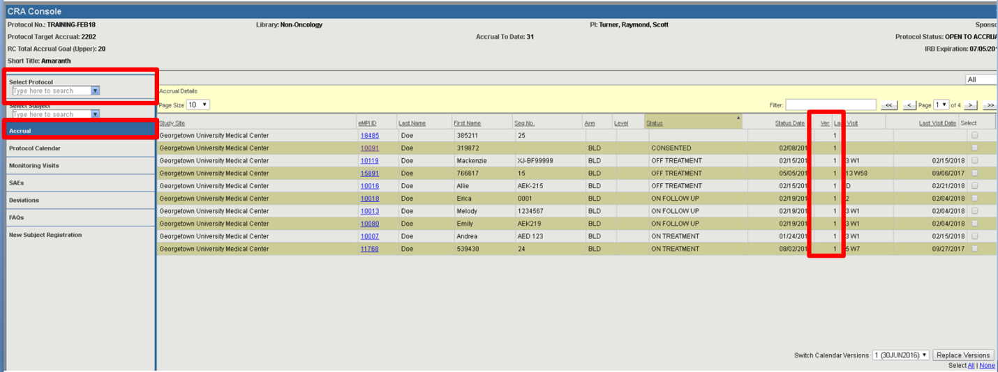

- Use the Select checkboxes to select one or more subjects for which you would like to update the calendar version. You may also use the Select All hyperlink to select all of the subjects in view.
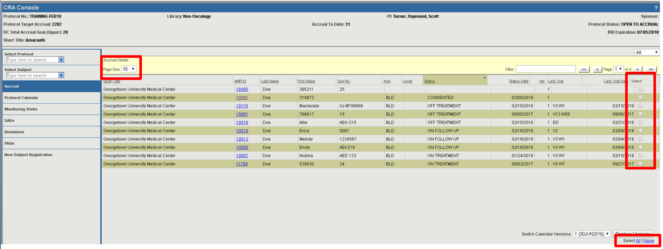

Keep in mind that Select All will only select the subjects on the current page. You may want to adjust your page size so you can see and select all of your subjects at once.

- Use the Switch Calendar Versions drop-down to select the desired calendar version, and then click Replace Versions.
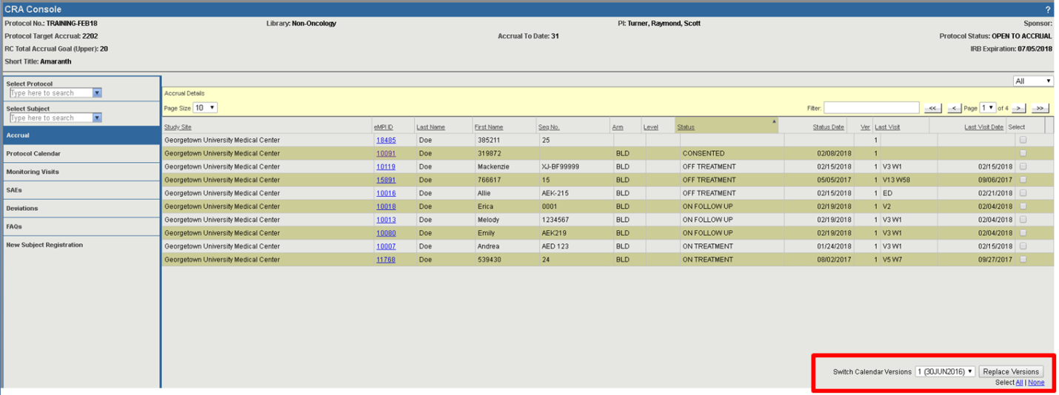

- You will receive a message confirming the calendar version update. Click OK.
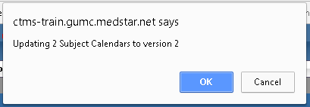
- Verify that the Ver column now shows the correct calendar version for you subject(s).

