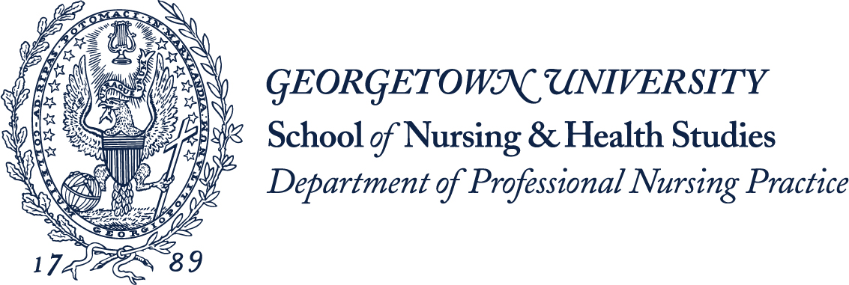
The purpose of this Honors Program is to allow those students in the undergraduate nursing major with academic potential to be challenged at the highest level.
Participants in the Nursing Honors Program will address, through scholarly inquiry, a contemporary issue related to clinical nursing practice. The Honors Program is a three semester program that requires an independent research project, policy analysis, or health/illness education project. Students apply research methodology to their chosen area of study while using the Georgetown Nursing Values Model.
The culmination of the student’s project leads to both an oral presentation and completion of a senior honors thesis. All participants are required to pass the oral presentation and senior honors thesis as determined by the assigned review committee. Prior to graduation, participants in the Honors Program are expected to disseminate the results of their senior honors project. One honors student will serve as the student representative for the Council on the Advancement of Nursing Science (CANS).
Participants in the Honors Program are expected to complete all requirements for the nursing major, maintain a cumulative GPA of 3.50, and successfully complete the three Honors Seminars.
Traditional nursing students with a GPA of 3.50 or higher are eligible to apply; the application deadline is mid-October and will be posted for students in their junior year.
Each applicant must submit a personal statement, two letters of recommendation (one must be from a clinical instructor), a copy of his/her unofficial transcript, and schedule an interview with the CANS. The letter of recommendation must specifically address the following qualities: focus, purpose, individual strengths and potential for advanced inquiry. All acceptances into the program are contingent on the maintenance of a GPA of 3.50 fall semester of the junior year.
The applicants’ personal statement should include an overview of their proposed scholarly inquiry and a plan for completing the project. It should clearly articulate the topic of scholarly inquiry and, during their interview the students are expected to elaborate on the topic outlined in their personal statement. The scholarly topic needs to be finalized by the end of the first semester in the program.
Students who successfully complete the requirements of the honors program will graduate with a Bachelor of Science in Nursing with their specific honors designation.

