Tip Sheet: The Radiology Research Support Request Process and OnCore
The Radiology Research Support Process ensures that necessary resources and personnel are in place to complete your study. Follow these steps to complete the process.

1. Access the MGUH Radiology Research Support Request Form in OnCore
- When logged into OnCore, access the dropdown under your username, and choose the Help menu, and select the Georgetown Radiology Support Request Form option.
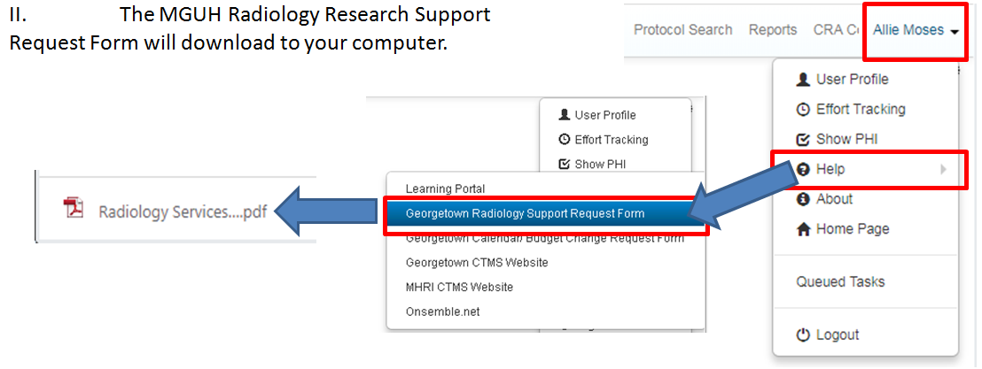

2. Complete the MGUH Radiology Research Support Request Form and send the completed form to GUH-RadiologyResearch@gunet.georgetown.edu

3. The radiology team will review the support request and sign off if all requested services are feasible.

4. Upload the signed form to the Protocol Documents in OnCore.
- Navigate to the Menu> Protocols> PC Console. Select your study and access the Documents/Info tab.
- Click Update, then Add.
- Choose the Document Type of Radiology Services Support Request, and enter the date signed as the Version Date. Choose to attach a file and select the signed form from your documents. Click Add.
